

“Modern Web Development Workflow”

Project Report submitted in partial fulfillment of the requirements for the award of the degree of

BACHELOR OF COMPUTER APPLICATION


Submitted By

Anand Khandelwal

25BCYC12
Under the guidance of

Dr. K.Kalaiselvi

SCHOOL OF COMPUTATIONAL AND PHYSICAL SCIENCES
DEPARTMENT OF COMPUTER SCIENCE
BCA/B.Sc PROGRAMME

KRISTU JAYANTI [Deemed to be University]
K. Narayanapura, Kothanur P.O., Bangalore – 560077



DEPARTMENT OF COMPUTER SCIENCE

CERTIFICATE OF COMPLETION

This is to certify that the project entitled “Mordern Web Development Workflow ” has been satisfactorily completed by 25BCYC12, Anand Khandelwal in partial fulfillment of the award of the Bachelor of Computer Applications degree requirements prescribed by Kristu Jayanti [Deemed to be University] Bengaluru during the academic year 2025 -26.

Internal Guide Head of the Department



DECLARATION

I, 25BCYC12, Anand Khandelwal hereby declare that the project work entitled ‘Mordern Web Development Workflow’ is an original project work carried out by me, under the guidance of Dr. K.Kalaiselvi.

Signature

Bengaluru Date:

TABLE OF CONTENTS

Sl. No | Topics | Pages
1 | Introduction | 5
2 | Tools and Technologies used | 6
3 | Modern Web Development Workflow | 7
4 | Screenshots | 8-10
5 | Conclusion | 11
6 | References | 12

INTRODUCTION

This project demonstrates the implementation of a modern web development workflow by creating a single-page portfolio website. The website presents personal details such as education, interests, and skills, along with a contact form that allows users to send messages directly.
The project is built using a combination of frontend, backend, and database technologies. The frontend is developed using HTML (Hyper Text Markup Language), which is used to structure the web pages, CSS (Cascading Style Sheets), which is used for designing and styling the layout, and JavaScript, which adds interactivity and handles form validation.
The backend is developed using Node.js, which is a JavaScript runtime environment that allows execution of JavaScript on the server side, and Express.js, which is a web framework used to handle server requests and create APIs.
The project uses MongoDB, a NoSQL database that stores data in a flexible JSON-like format, to save user messages submitted through the contact form.
For deployment, the application is hosted using Render, which is a cloud-based platform that allows developers to deploy web applications and make them accessible over the internet. It also supports automatic deployment when changes are pushed to GitHub.

Overall, this project helps in understanding how different components of web development—frontend, backend, database, and deployment—work together to build a complete and functional web application.

Tools and Technologies Used
The following tools and technologies were used in the development of this project:
Frontend technologies include HTML, CSS, and JavaScript. HTML (HyperText Markup Language) is used to create the structure of the web pages such as headings, sections, forms, and content layout. CSS (Cascading Style Sheets) is used for designing and styling the website, including colors, spacing, and layout. JavaScript is used to add interactivity, perform form validation, and send data to the backend using the Fetch API.

Backend technologies include Node.js and Express.js. Node.js is a JavaScript runtime environment that allows execution of JavaScript on the server side. Express.js is a web application framework used to create server-side logic, handle HTTP requests, and build APIs.

The database used in this project is MongoDB Atlas, which is a cloud-based NoSQL database used to store user data in a flexible JSON-like format. Mongoose is used as a library to define schemas and interact with MongoDB in a structured way.

For version control, Git is used to track changes in the project, and GitHub is used to host the project repository and manage different versions of the code.

The project is deployed using Render, which is a cloud-based platform that allows hosting of web applications and supports automatic deployment when changes are pushed to GitHub.

For development, Visual Studio Code is used as the code editor, and web browsers such as Google Chrome or Microsoft Edge are used for testing and running the website.

Modern Web Development Workflow
This project follows a modern web development workflow that involves multiple stages from development to deployment.

The first stage is local development, where the frontend and backend of the website are created using tools like Visual Studio Code. The frontend is developed using HTML, CSS, and JavaScript, while the backend is built using Node.js and Express.

The next stage is version control, where the project code is managed using Git and uploaded to GitHub. This helps in tracking changes and maintaining different versions of the project.

After development, the project is tested locally to ensure that all features such as form validation, API communication, and database connectivity are working correctly.
The frontend communicates with the backend through a REST API. When a user submits the contact form, the data is sent to the backend using the Fetch API with a POST request.

The backend processes the request and stores the data in MongoDB Atlas using Mongoose. This ensures that user messages are securely saved in the database.

Once the application is working correctly, it is deployed using Render, a cloud-based platform that hosts the backend server and makes the website accessible online.

The project also follows a CI/CD (Continuous Integration and Continuous Deployment) approach, where any changes pushed to GitHub are automatically deployed on Render without manual intervention.

Finally, users can access the website through a web browser and interact with its features in real time.

SCREENSHOTS

HERO SECTION-
ABOUT ME AND INTEREST SECTION-

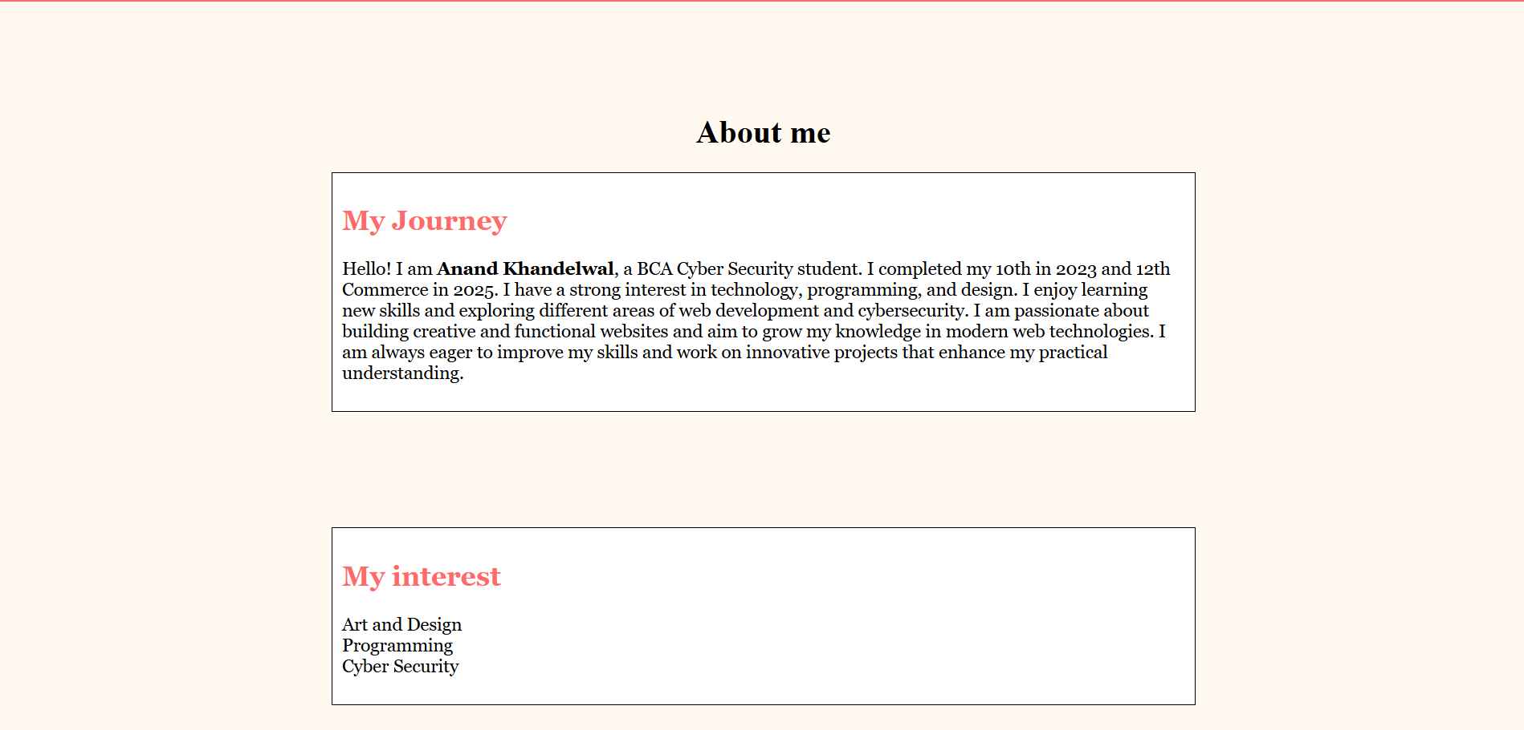
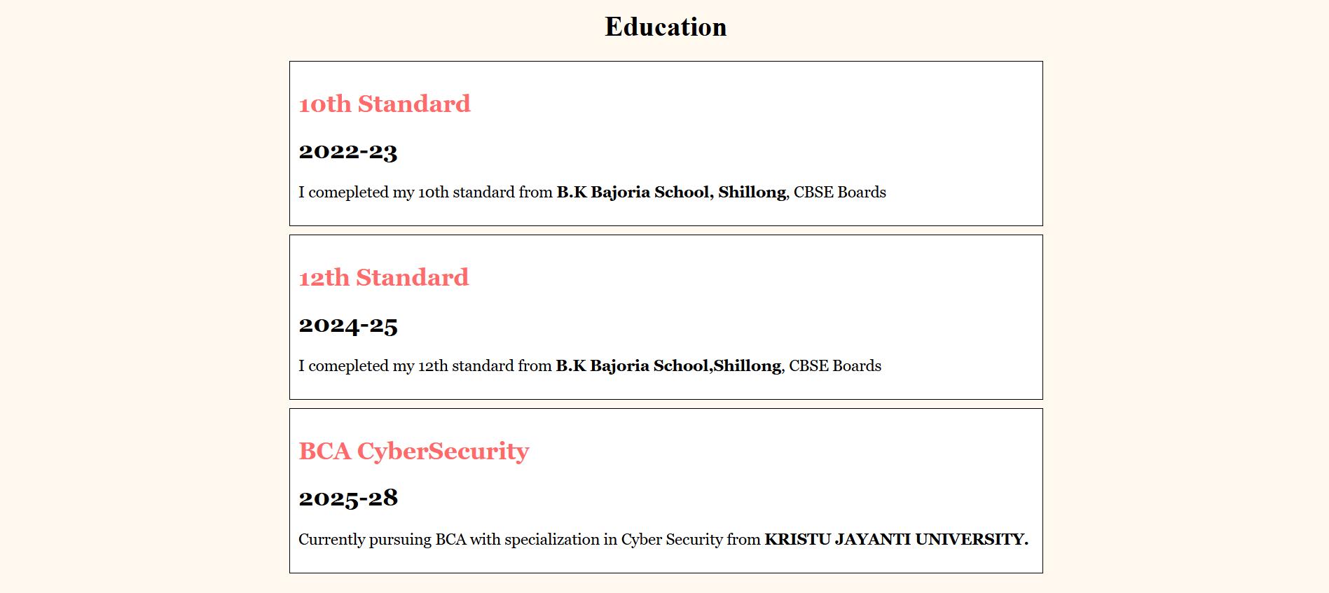
EDUCATION SECTION-

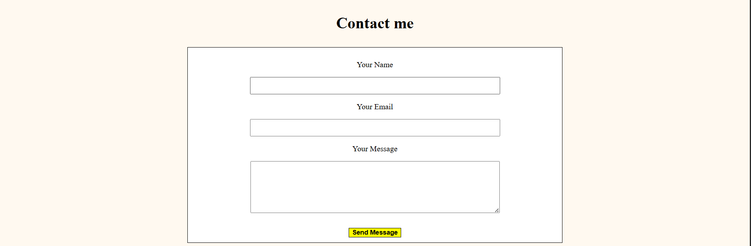
CONTACT ME FORM-

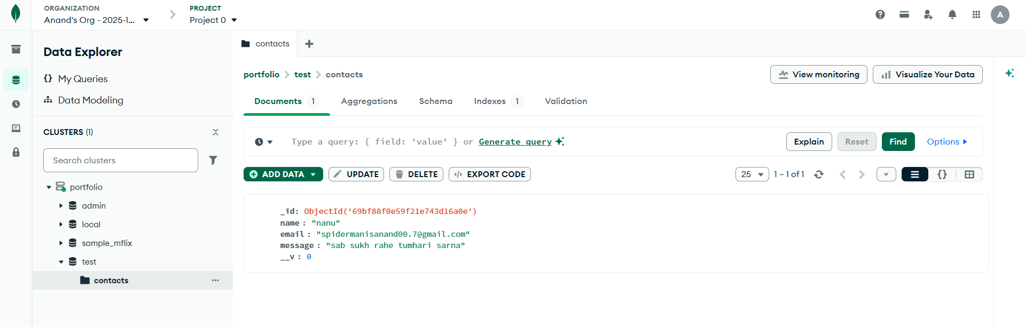
Mongo DB Database And GITHUB REPOSITORY-
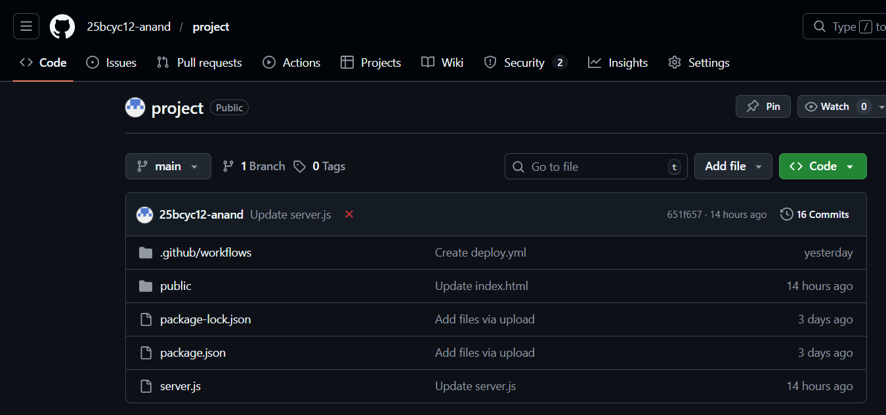

Conclusion

This project successfully demonstrates the implementation of a modern web development workflow by integrating frontend, backend, database, and deployment technologies. It helped in understanding how different components of a web application work together to provide a complete and functional system.

Through this project, practical knowledge was gained in designing user interfaces, handling user input, creating server-side logic, and storing data in a database. It also provided experience in using version control systems like Git and GitHub, as well as deploying applications using cloud platforms like Render.

The project follows a client-server architecture and uses REST API communication, which are widely used in real-world applications.

Overall, this project has enhanced understanding of full stack web development and modern development practices.

The project can be further improved by adding features such as email notifications, better user interface design, enhanced security, and advanced validation techniques.

References
1.ChatGPT: for guidance in understanding web development workflow and project building.
2. YouTube tutorials for learning concepts and implementation.
3. GeeksforGeeks – https://www.geeksforgeeks.org
4. W3Schools – https://www.w3schools.com
5. CSS Tricks – https://css-tricks.com
6.COOLERS-https://coolors.co
7. Web.dev by Google – https://web.dev

